**UNIVERSITI MALAYSIA TERENGGANU**

**BACHELOR OF COMPUTER SCIENCE (MOBILE COMPUTING)**

**WITH HONOURS**

**SEM 2 2022 / 2023**

**CSM 3103: FRONT-END PROGRAMMING (K2)**

**LAB REPORT 2**

**PREPARED BY:**

MUHAMMAD NAJMUDDIN BIN AZLI (S62728)

**LECTURER:**

DR. RABIEI BIN MAMAT



Write a step by step process based on your successful experience on How to install Apache Cordova

1. Download and install node.js
2. Open command prompt
3. Run npm install -g cordova

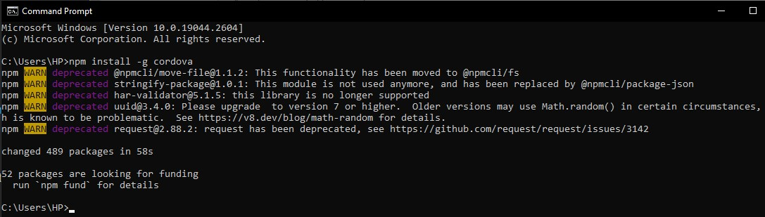



**a. Add browser platform to the project**  **b.** **Add android platform to the project**

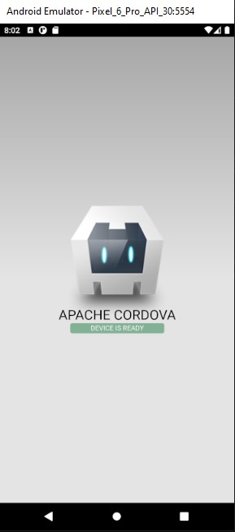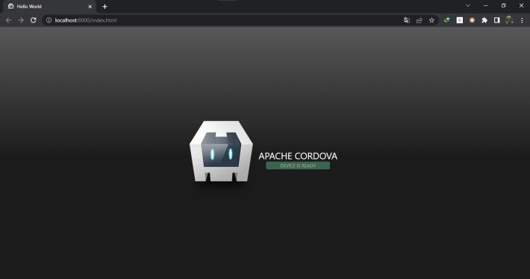



**a. Press volume down button b. Press back button**

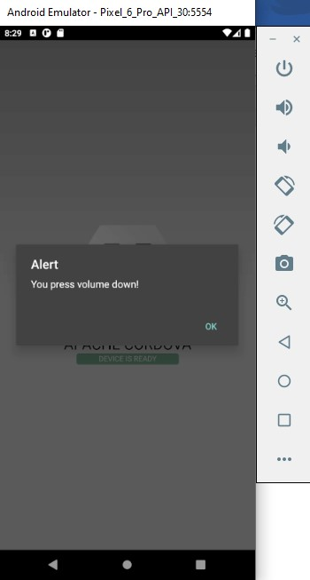 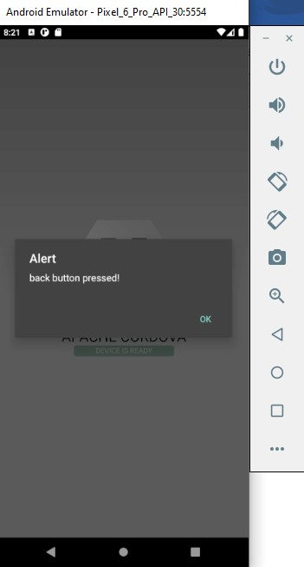

**What is the purpose of e.preventDefault()?**

*The purpose of e.preventDefault(), it prevents the default action that is associated with a specific event from taking place.*

**Do some research on how to add two controls to you index.js to do the following:**

**a. Handle volume up button b. Handle menu button**

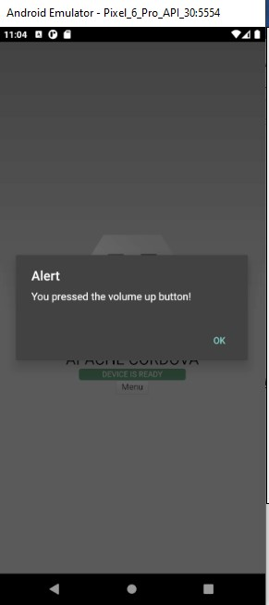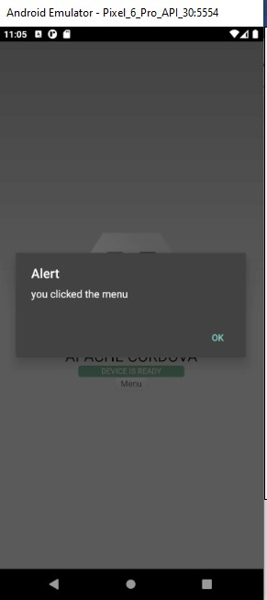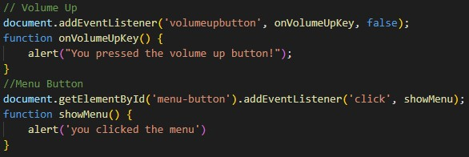

I

ndex.

js

**Source Code**

I

ndex.

html

